**Modeling and Simulation of Gear-Shift Controller**

ABSTRACT

Gear shift control of automated manual transmissions (AMT) has many advantages in terms of improvement of driving comfort, reduction of fuel consumption and shifting quality. This project aims to present a mathematical model, simulation, for gear-shift controller. The mathematical and the control logic for the model have been developed using MATLAB/Simulink software tool.

INTRODUCTION

An automatic transmission is a multi-speed transmission used in motor vehicles that does not require any driver input to change gears under normal driving conditions. In this project an automotive drivetrain is modelled with Simulink.

Simulink provides a powerful environment for the modeling and simulation of dynamic systems and processes. In many systems, though, supervisory functions like changing modes or invoking new gain schedules must respond to events that may occur and conditions that develop over time. As a result, the environment requires a language capable of managing these multiple modes and developing conditions. In the following example, Stateflow shows its strength in this capacity by performing the function of gear selection in an automatic. This function is combined with the drivetrain dynamics in a natural and intuitive manner by incorporating a Stateflow block in the Simulink block diagram.

BLOCK DIAGRAM

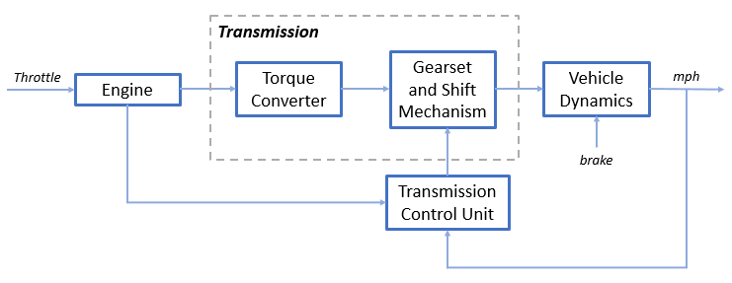

Equations used in modelling:

Equation 1

= engine speed (RPM)

= moment of inertia of the engine and the impeller

Equation 2

= K-factor (capacity)

= speed of turbine (torque conversion output) = transmission input speed (RPM)

= torque ratio

Equation 3

= transmission ratio

= transmission input and output torque

= transmission input and output speed (RPM)

Equation 4

vehicle inertia, = wheel speed (RPM), final drive ratio

load torque

Equation 5

= friction and aerodynamic drag coefficient

load and brake torque

= vehicle linear velocity

IMPLEMENTED MODEL

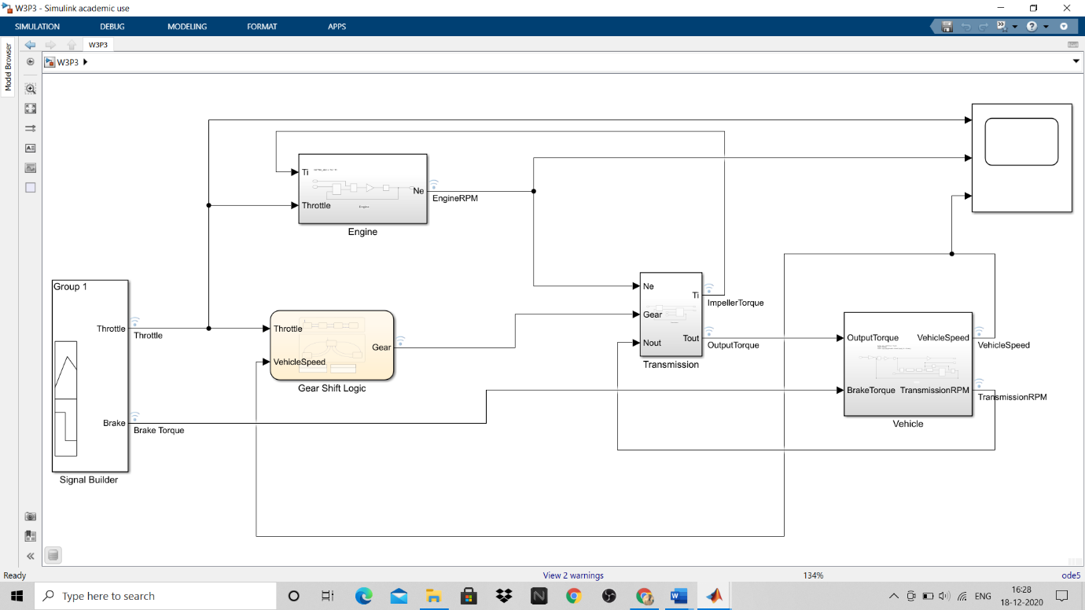

GEAR SHIFT LOGIC STATEFLOW MODEL

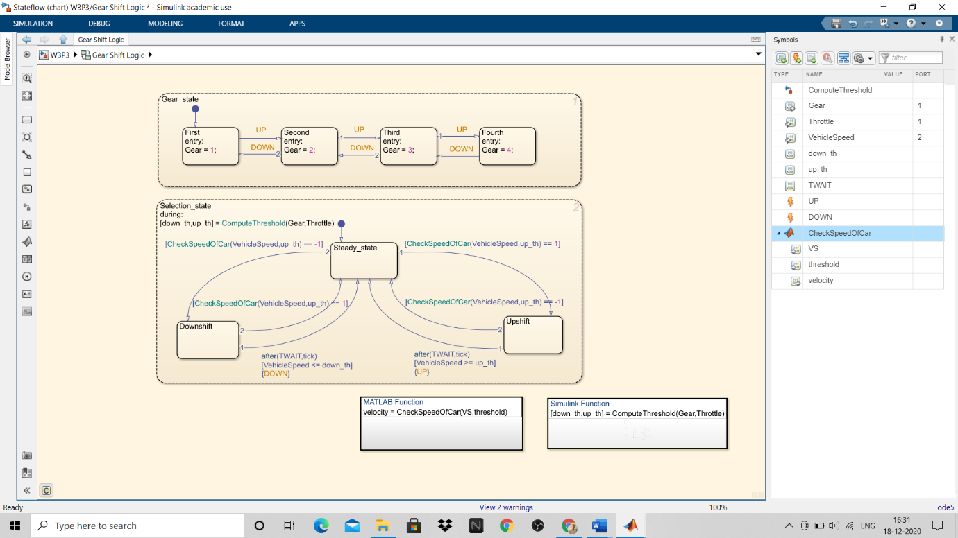

MATLAB FUNCTION

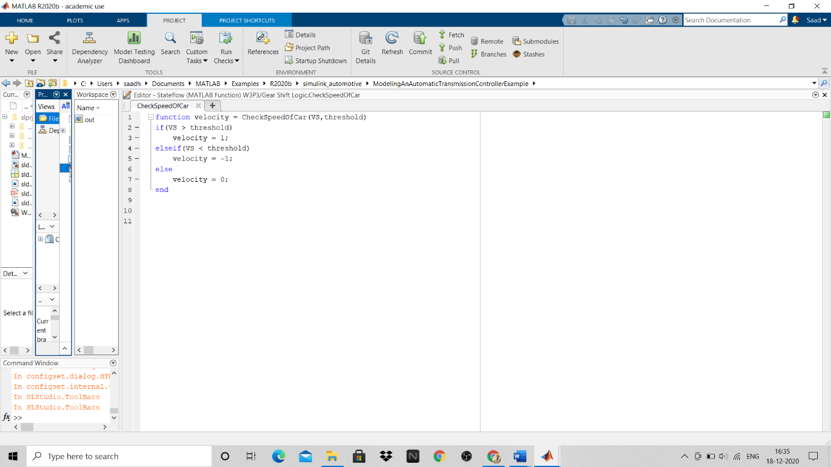

DATA DICTIONARY

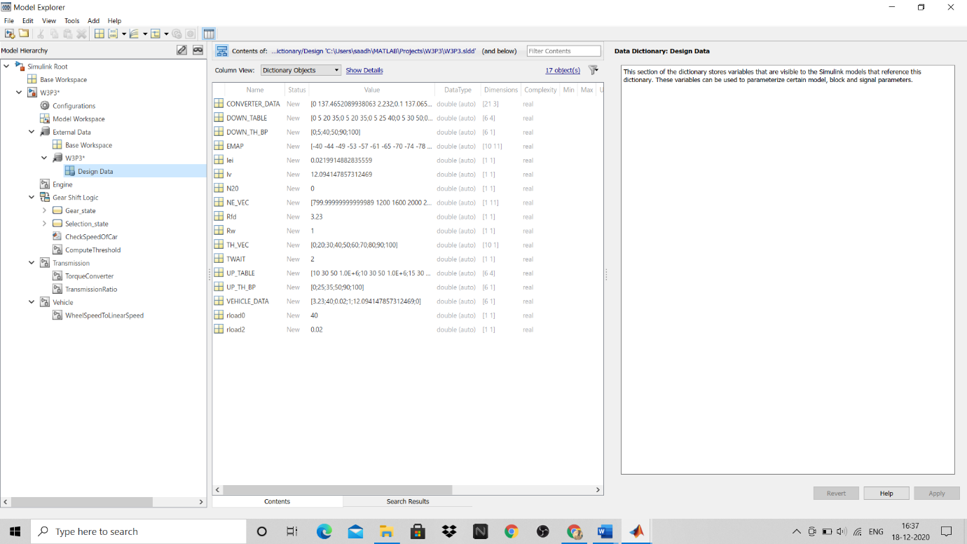

CALLBACKS

Variables used in this model are stored in PreLoad functions of Model callbacks

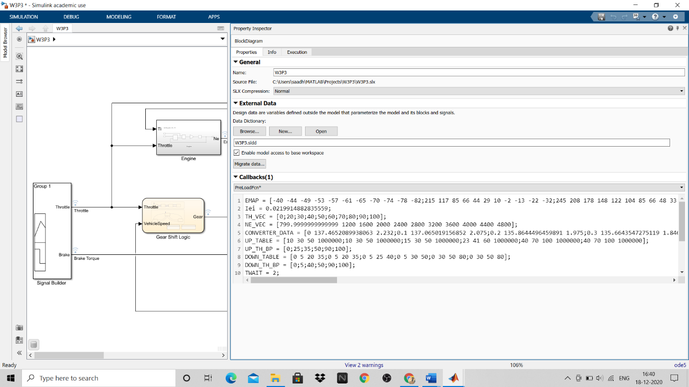

SOLVER SELECTION

For this project Fixed step ode5 solver has been taken as fixed-step solvers are typically used for to meet accuracy requirements and are used when models will be deployed onto hardware such as microcontrollers (keyword: code generation).

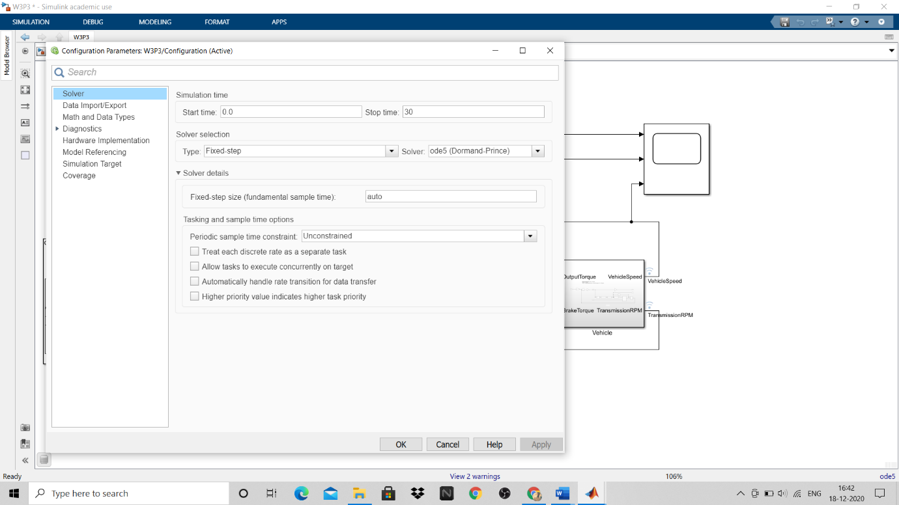

DATA INSPECTOR RESULTS

SIMULATION 1:

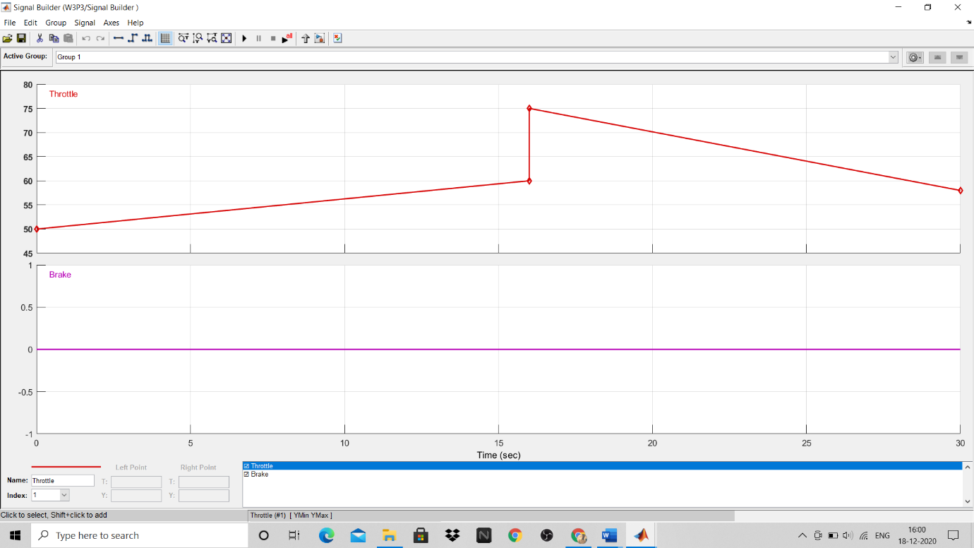

Test signal 1

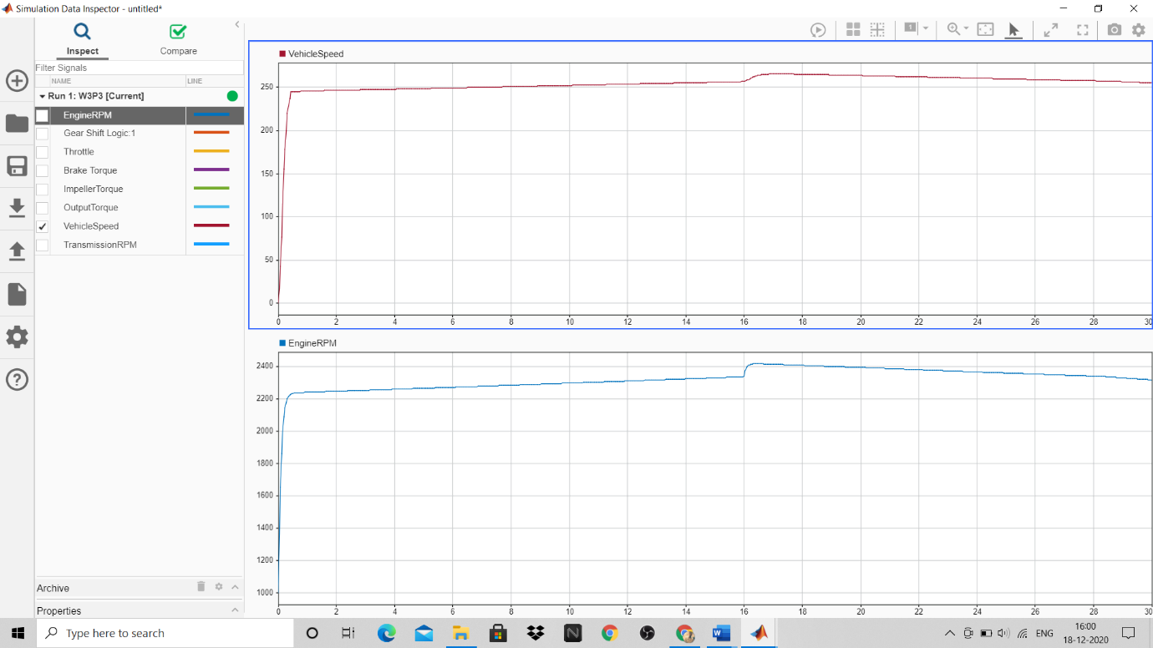

Output Signal 1

SIMULATION 2:

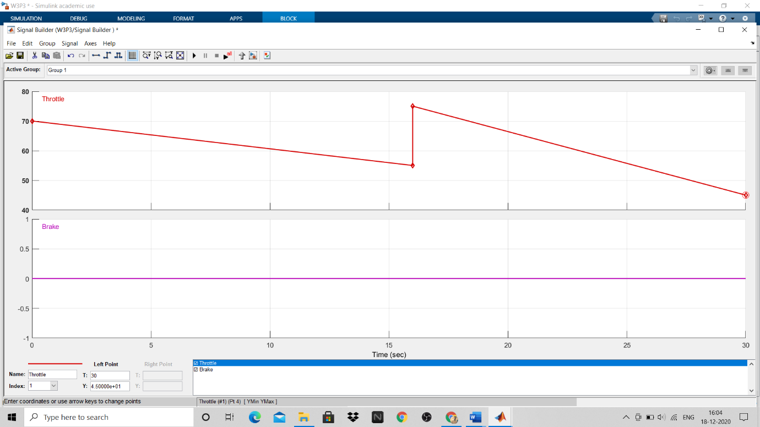

Test signal 2

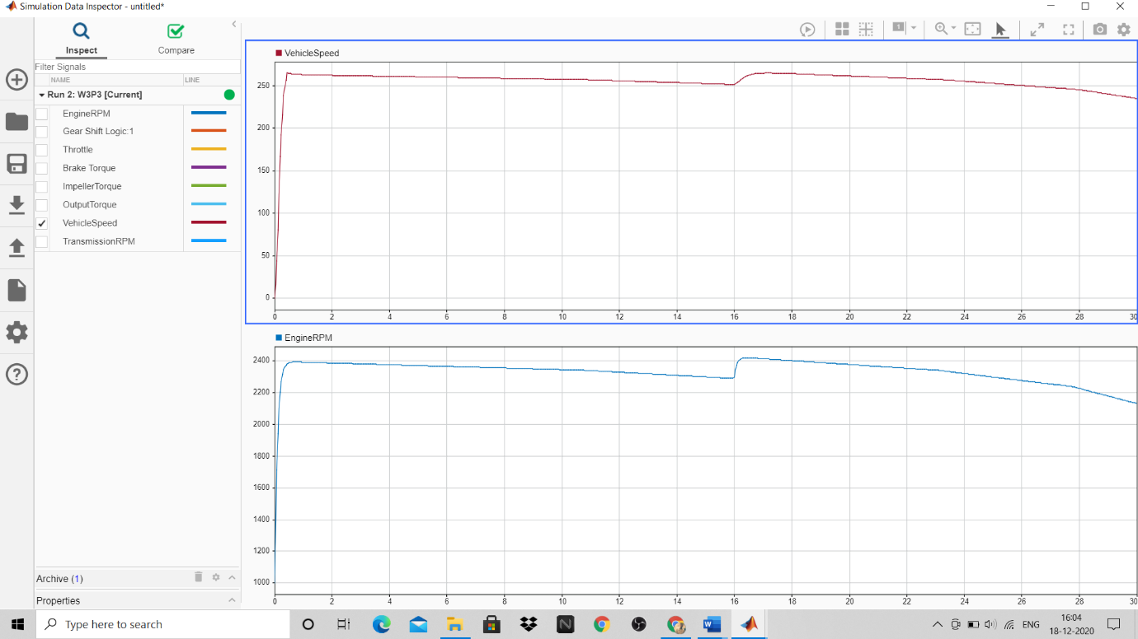

Output signal 2

SIMULATION 3:

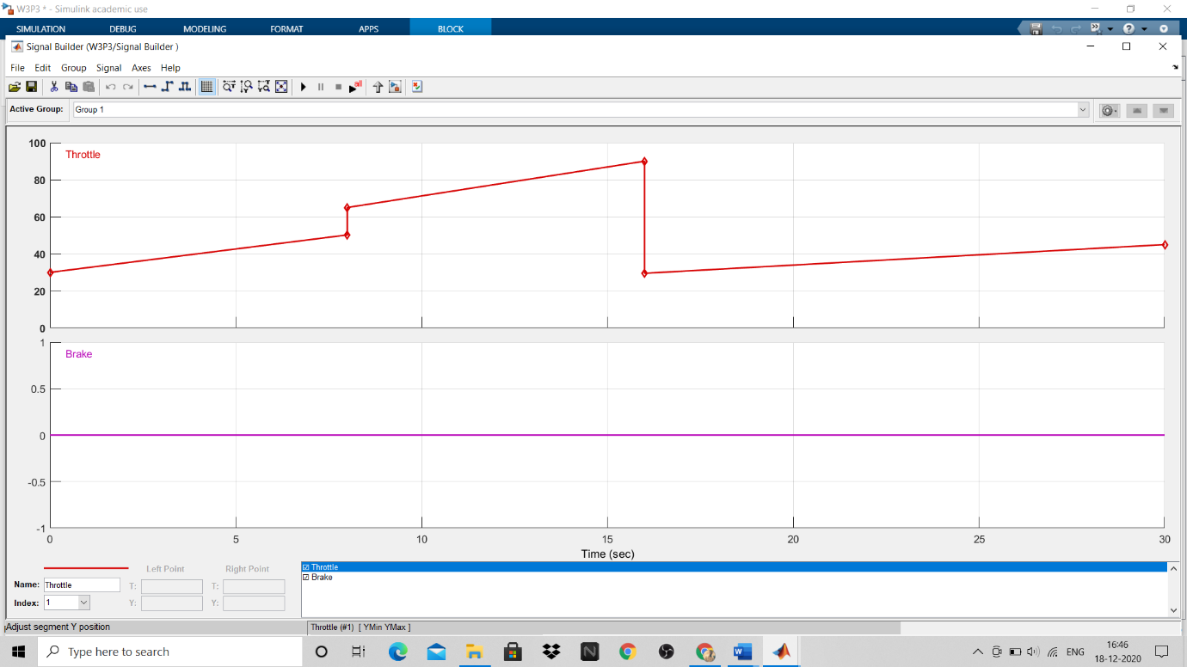

Test signal 3

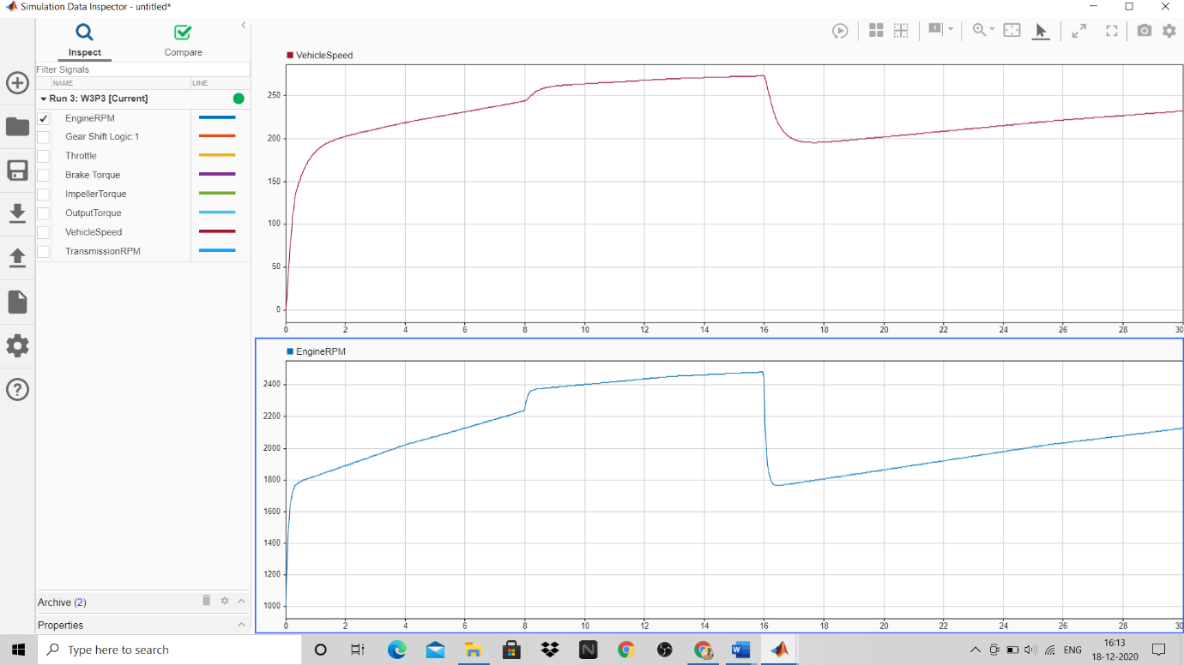

Output Signal 3

REFERENCES

1. Automat Transmission Controller-<https://in.mathworks.com/help/simulink/slref/modeling-an-automatic-transmission-controller.html>.
2. Solver selection methods-

<https://blogs.mathworks.com/racing-lounge/2017/12/08/solver-choice>